**NO SQL ASSIGNMENT**

1. Create a keyspace for the application. Keyspace name: `tranz`.



2.Create a table for drivers if not exists. Table name: `driver`. Columns: `driver_name` (unique, if not exists, primary key), `password` (string), `mobile` (number), `current_position` (string), `skill` (`set` type with strings).

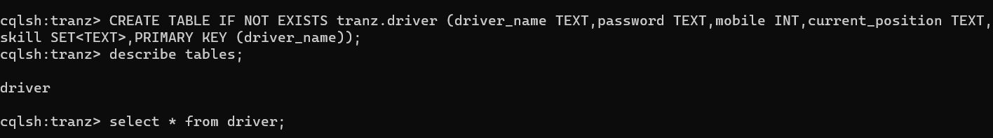

3.Create index We will filter drivers by skill ,password and current_position. So create index on both.



4 Create a table for vehicles. Table name: `vehicle`. Columns: `vehicle_id` (string, unique, if not exists), `status` (string), type (string)



5. create index on status.



6. Create a table for timetables. Table name: `time_table`. Columns: `line_name` (unique, if not exists, string), `service_no` (number, asc within line_name), `station_name` (string), `latitude` (double), `longitude` (double), `time` (int), `distance` (double), Notes: time are departure times, except the last (destination) time, it is arrival time. Sorted `asc` by `time`.

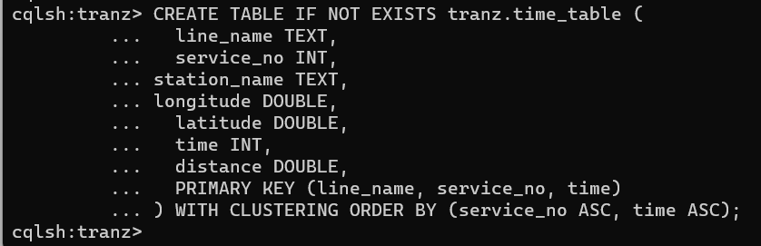

7.Insert the values into the table driver.

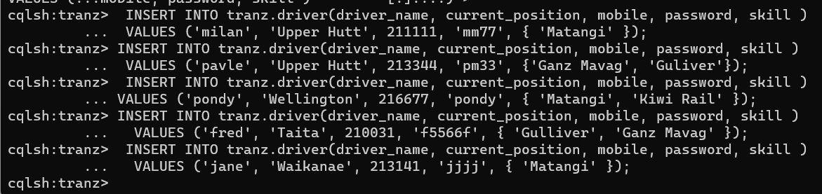

8 Drivers can change their password. They provide `old_password` and `new_password`. Update the driver's row with `new_password` only if the `old_password` equal with the stored `password`. If the conditions apply, `password` will be equal with `new_password`.



9. Drivers can update their `current_position`: (with city name string) `'Wellington'` OR (with vehicle) `vehicle_id` OR (with not available string constant) `'not_available'`. The update process managed by the app, based on the driver's skill and the location of the train.

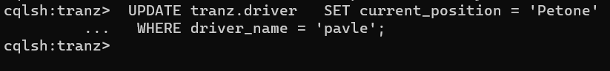

10. Seed the initial vehicles data.

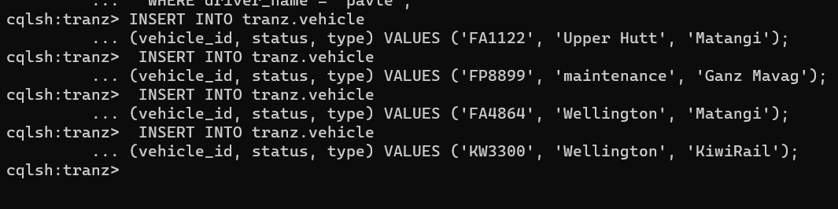

11. Seed `time_table.

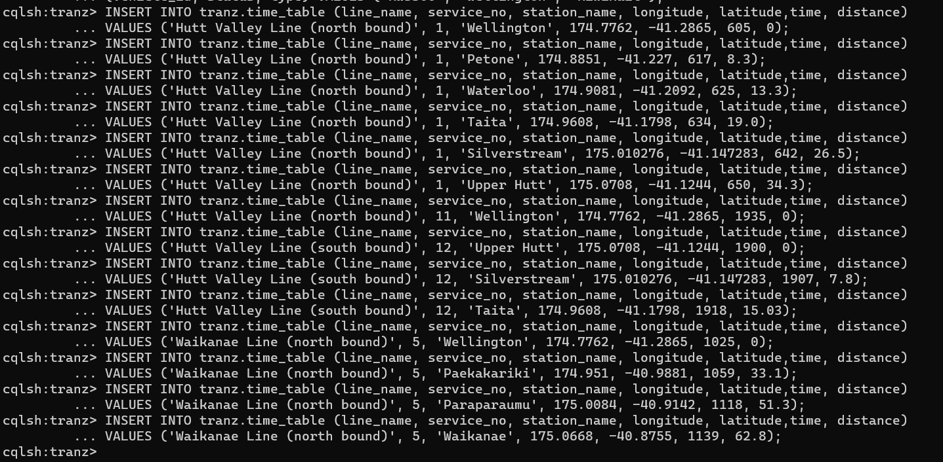

12. Read timetable data for showing timetable for passengers. Requested columns from `time_table` table: `line_name`, `station_name`, `time`.

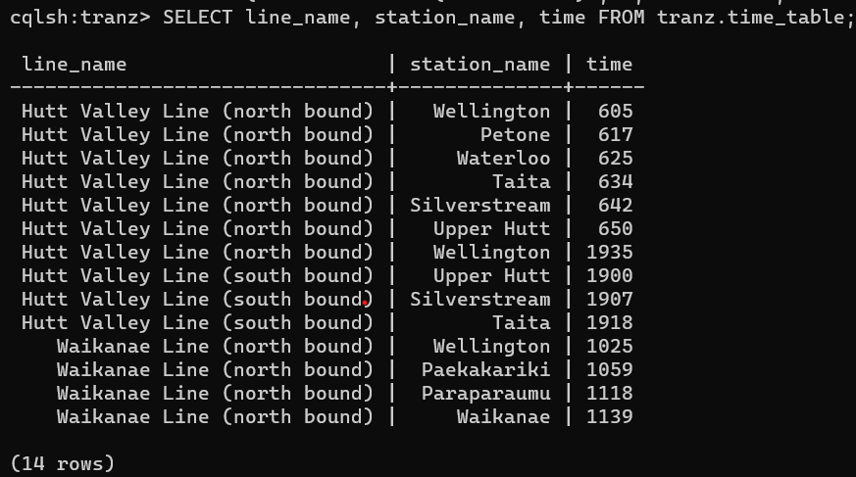

13. Application can list `station_name`, `service_no`, `time` from `time_table`. `desc` sorted by `time`.

-- The sorting is ASC in this table, the data will be provided as ordered by ASC.

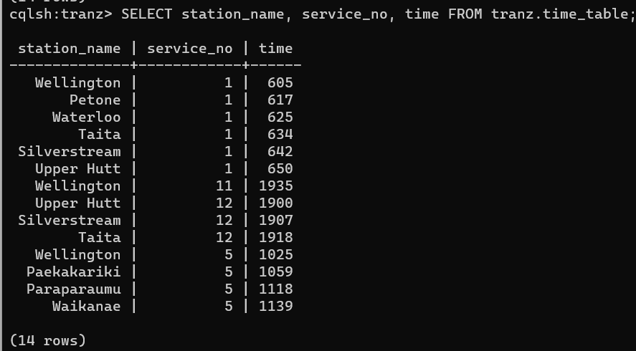

14. The iPhone app, which is on the train can read `station_name`, `time`, `line_name`, `service_no..Display the fields when line_name=’ 'Hutt Valley Line (north bound)' AND service_no = 11 limiting to the first document.

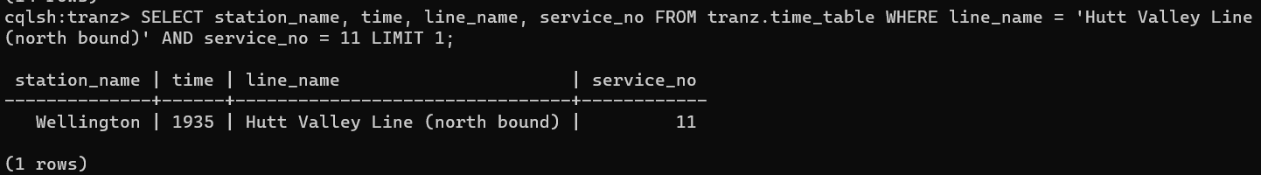

15. The application runs a query to list trains on a station. Find the details when current_position = 'Wellington' and skill is 'Matangi.

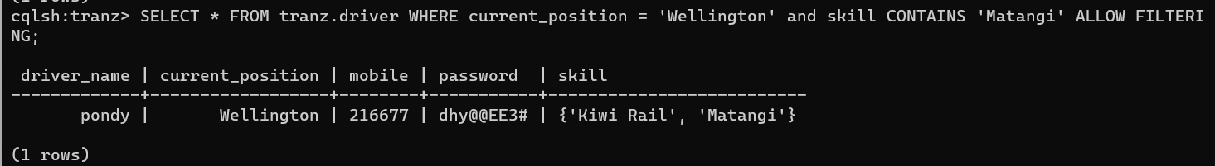

16. -- Return the `driver_name` if the provided authentication data is right, otherwise no matching data, return an empty table.

